**Batch:A3 Roll No.:16010421119 Experiment No.:07**

**Output:**

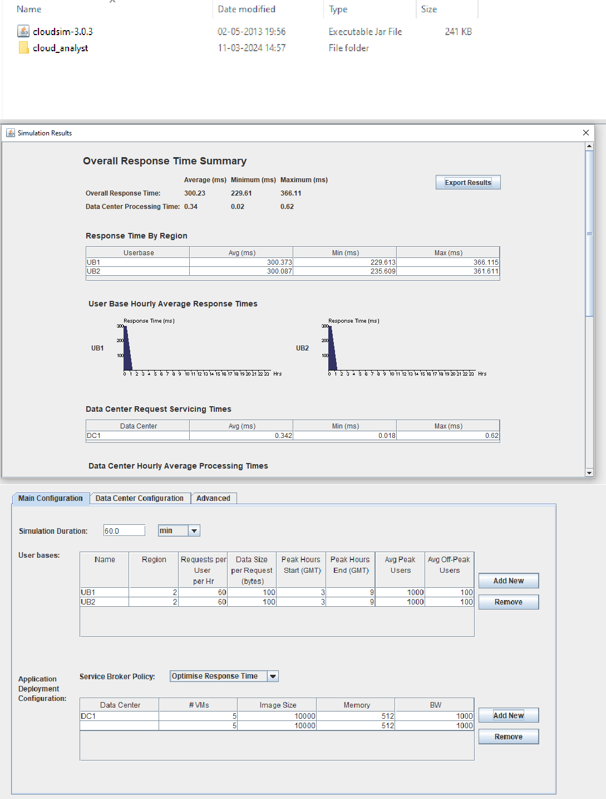

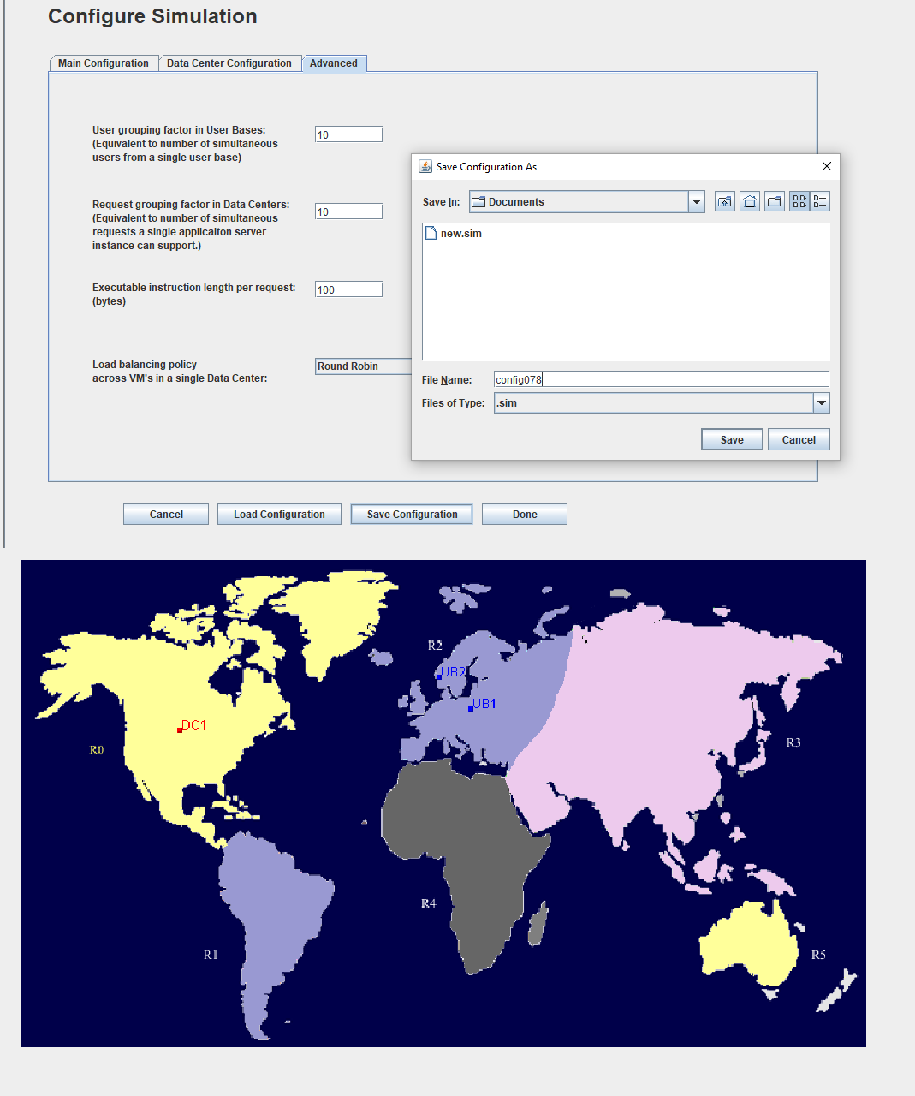

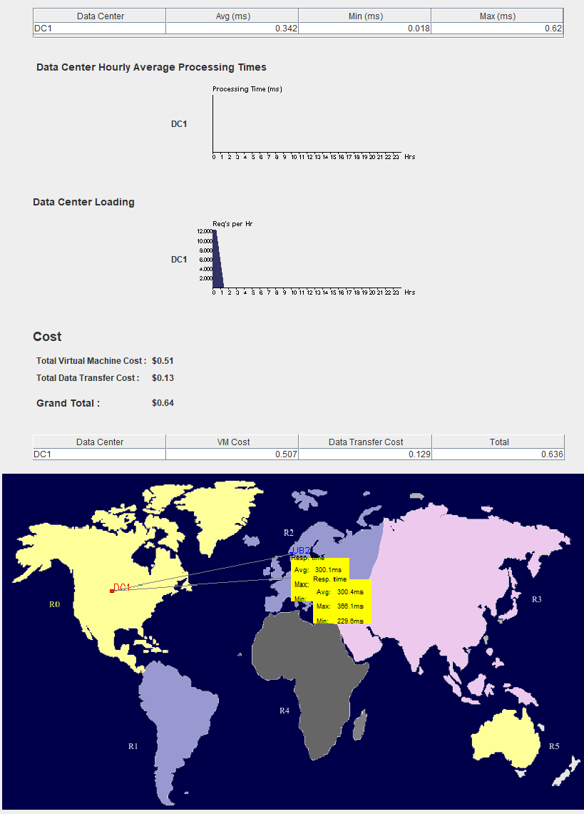

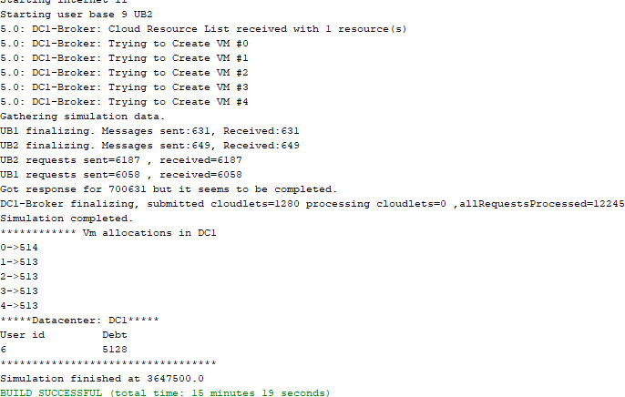

**Post Lab Questions:**

1. **Explain Cloud Analyst Design with neat diagram**

Cloud Analyst is a simulation tool used for modeling and analysis of cloud computing infrastructures and services. It's primarily employed in research and academic environments to study the behavior and performance of cloud systems under different conditions. Here's a brief overview of its design:

* 1. Simulation Environment: Cloud Analyst provides a virtual environment where users can simulate various aspects of cloud computing, including the deployment of virtual machines (VMs), networking configurations, and workload management.
  2. Modeling Infrastructure: Users can model different components of cloud infrastructure such as data centers, physical servers, networking equipment, and storage resources. This allows for the creation of realistic simulations that mimic real-world cloud environments.
  3. Workload Generation: Cloud Analyst allows users to define and generate workloads to simulate the demand on the cloud infrastructure. Workloads can vary in terms of intensity, types of applications, and resource requirements.
  4. Performance Metrics: The tool provides a range of performance metrics and analytics to evaluate the behavior of the cloud system. These metrics may include response time, throughput, resource utilization, and scalability.
  5. Visualization: Cloud Analyst offers visualization capabilities to represent the simulation results graphically. This helps users to interpret the data more easily and gain insights into the performance of the cloud infrastructure under study.
  6. Experimentation and Analysis: Users can conduct various experiments within the simulation environment to analyze the impact of different parameters and configurations on the performance and efficiency of the cloud system.

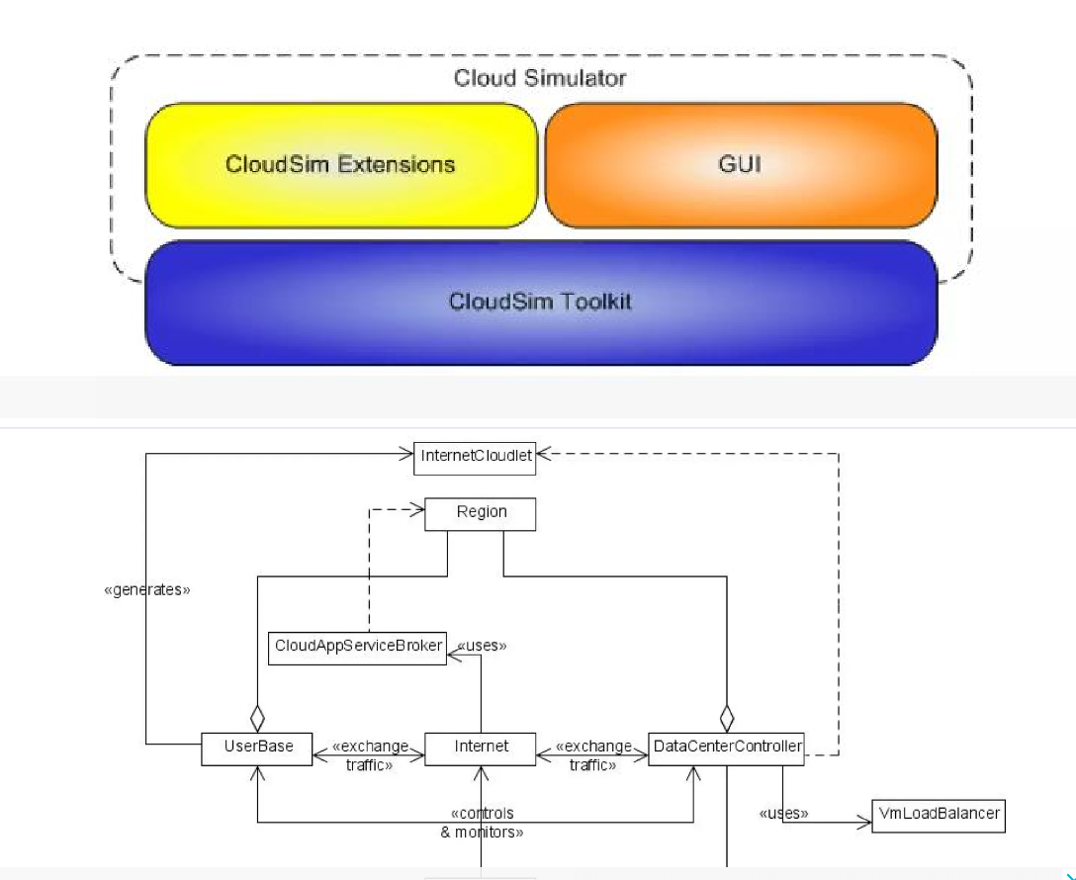

**Outcomes:**

**CO3 Analyze different cloud architectures**

**Conclusion: (Conclusion to be based on the objectives and outcomes achieved) In this experiment, we learnt how to perform Cloud simulation using CloudSim.**